SIMATS ENGINEERING
ASSESSMENT TOOL 2 – Scenario-Based
Course Name: Cloud Computing and Big Data Analytics
Course Code: CSA15
Course Outcome (CO2):
Analyze virtualization architectures to identify performance and security issues in cloud computing environments. (BL3)
Dave's Taxonomy: Manipulation (Level 2)
Total Marks: 25

Submitted By
Name: Keerthana P
Register Number: 192521289

Scenario-Based Questions with Answers
Question 1
Scenario
A media company wants to migrate its video streaming platform to the cloud. The system must support millions of concurrent users with minimal buffering.
Cloud Architecture Design
- Deploy application servers on multiple Virtual Machines (VMs) or containers.
- Store videos in cloud object storage.
- Use a Content Delivery Network (CDN) to deliver videos from the nearest location.
- Use a caching service to store frequently watched videos.
- Place a load balancer in front of application servers.
- Enable Auto Scaling to increase or decrease servers automatically.
Load Balancing and Auto Scaling
- Load Balancer
  - Distributes user requests evenly.
  - Prevents server overload.
  - Improves response time.
- Auto Scaling
  - Adds new servers during peak traffic.
  - Removes unused servers during low traffic.
  - Maintains smooth video streaming.
Cost Optimization
- Use Auto Scaling to avoid paying for idle servers.
- Store old videos in low-cost cloud storage.
- Use Reserved Instances for predictable workloads.
- Compress videos to reduce storage and bandwidth costs.
- Cache popular videos to reduce repeated server requests.
Diagram :

Conclusion
Using cloud scalability, caching, CDN, load balancing, and Auto Scaling provides high performance while reducing operational cost.

Question 2
Scenario
A fintech startup deploys applications using containers across multiple cloud providers.
Solution
- Package applications using Docker containers.
- Use Kubernetes for container orchestration.
- Deploy Kubernetes clusters across multiple cloud providers.
- Store container images in a secure container registry.
Service Discovery and Scaling
- Kubernetes automatically discovers running services.
- Internal DNS allows containers to communicate.
- Horizontal Pod Autoscaler increases or decreases pods based on CPU and memory usage.
- Load balancer distributes traffic among containers.
Benefits of Multi-Cloud
- High availability.
- Avoids vendor lock-in.
- Better disaster recovery.
- Improved flexibility.
- Increased reliability.
Risks
- More complex management.
- Higher operational cost.
- Security policy differences.
- Data synchronization challenges.
- Network latency between cloud providers.

Diagram :

Conclusion
Container orchestration with Kubernetes ensures consistent deployment while multi-cloud improves availability and reliability.

Question 3
Scenario
An e-learning platform loses important data due to accidental deletion.
Backup and Disaster Recovery Solution
- Enable automatic cloud backups.
- Enable object versioning.
- Replicate data to another region.
- Schedule daily and weekly backups.
- Store backups in secure cloud storage.
RTO and RPO
- RTO (Recovery Time Objective):
  - Minimize downtime using replicated servers and automated recovery.
- RPO (Recovery Point Objective):
  - Frequent backups ensure only minimal recent data is lost.
Business Continuity Steps
- Enable automatic backups.
- Replicate data across regions.
- Perform regular recovery testing.
- Monitor backup status.
- Create a disaster recovery plan.
- Train administrators for emergency recovery.
Conclusion
Cloud-native backup, replication, and versioning ensure fast recovery with minimal data loss.

Question 4
Scenario
A government agency adopts a hybrid cloud model for sensitive and non-sensitive data.
Hybrid Cloud Architecture
- Keep sensitive applications on-premises.
- Store public applications in the public cloud.
- Connect both environments using secure VPN or dedicated connection.
- Synchronize required data securely.
Identity Management and Encryption
- Use Identity and Access Management (IAM).
- Implement Multi-Factor Authentication (MFA).
- Encrypt data during transmission using TLS.
- Encrypt stored data using AES-256 encryption.
- Apply role-based access control (RBAC).
Challenges
- Complex infrastructure management.
- Compliance requirements.
- Network latency.
- Data synchronization issues.
- Higher maintenance cost.
- Security policy integration.
Conclusion
Hybrid cloud provides flexibility while ensuring sensitive government data remains secure and compliant.

Question 5
Scenario
A SaaS provider needs high availability even if one cloud region fails.
Multi-Region Deployment Strategy
- Deploy application servers in two or more regions.
- Use a Global Load Balancer.
- Maintain identical application environments.
- Synchronize databases across regions.
Data Replication and Failover
- Enable real-time database replication.
- Configure automatic failover.
- Redirect traffic to healthy regions during failures.
- Perform regular failover testing.
Monitoring and Alerting
- Monitor CPU, memory, storage, and network usage.
- Configure alerts for failures and high resource usage.
- Monitor application logs.
- Enable automated notifications.
- Use dashboards for real-time monitoring.

Multi region format :
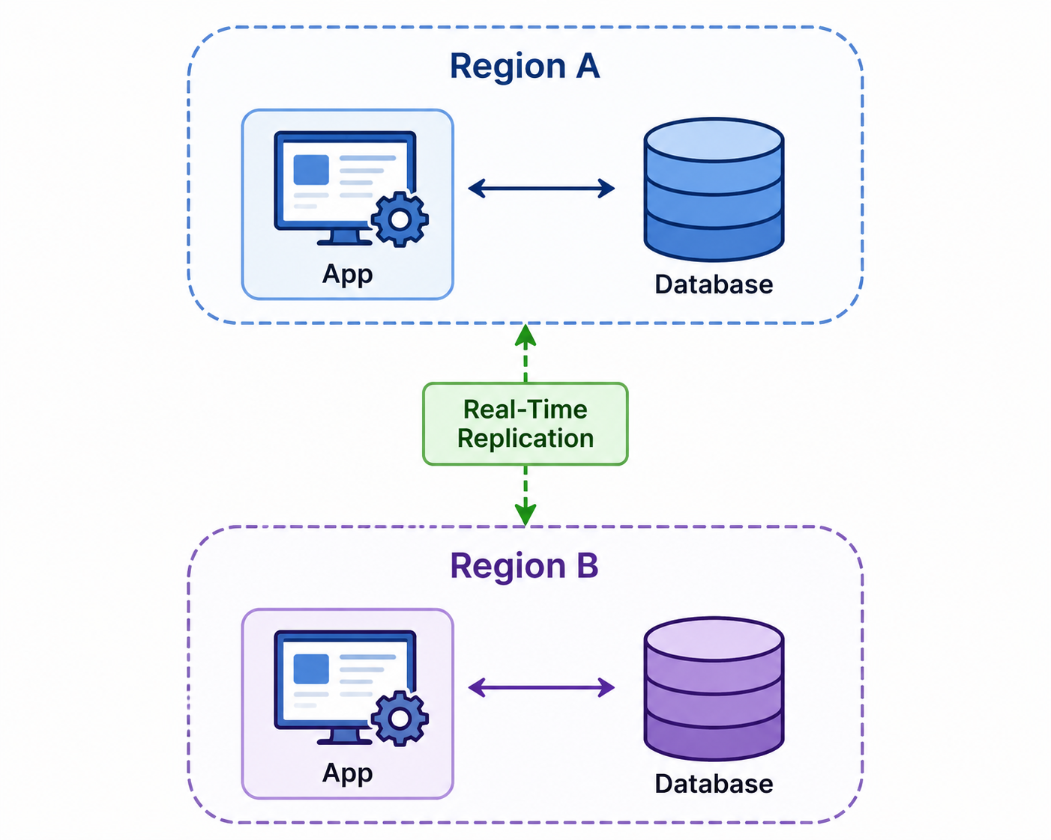

Conclusion
Multi-region deployment with replication, failover, and continuous monitoring ensures maximum availability and fault tolerance.

Overall Conclusion
Cloud computing provides scalable, reliable, and secure infrastructure for modern applications. Technologies such as virtualization, load balancing, auto-scaling, container orchestration, backup, disaster recovery, hybrid cloud, and multi-region deployment improve performance, ensure business continuity, and reduce operational costs. These solutions help organizations deliver highly available and secure cloud services efficiently.

